Machine Learning

10-601B – Homework - 7

Sam David Christ Doss Pushpam

4. Feature Visualization

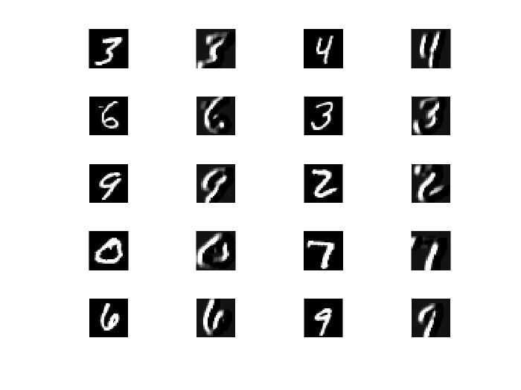

This filter seems to detect the vertical lines. From the different output images, it looks like it’s getting the vertical lines, but some diagonal lines are also detected.